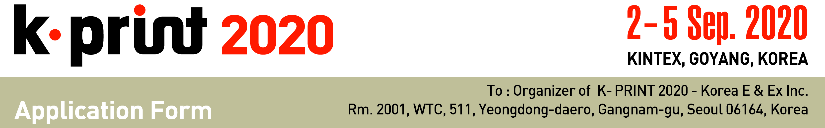

1. Exhibition Choice [√ Please tick an exhibition which you wish to participate in.]
- KIPES | - K-Label | - K-Pack | - K-Digi Print | - K-Textile | - K-Sign & AD

2. Applicant □ Manufacturer □ Importer
Company Name
Company Details | Address
 | Country |  | Tel
 | URL |  | Fax
Contact | Name |  | E-mail
 | Dept. |  | Position
□ Please contact our Korean agent/representative for further communication
Agent Name |  |  | Tel
Contact Person |  |  | Fax

3. Type of Booth Space [ 1 booth: 3 x 3= 9sqm]
□ Space Only | USD 2,600 x Booth(s) = USD
□ Shell Scheme | USD 3,400 x Booth(s) = USD
* Special Benefit
1) Discount of K-PRINT 2018 Exhibitor : USD 100 Discount per 9sqm
2) Early Bird Benefit (Only applicable if 100% payment is received by below-due dates)
1st early bird deadline (USD 200 Discount per 9sqm) : 31. March, 2020
2nd early bird deadline (USD 100 Discount per 9sqm) : 29. May, 2020
* Benefit no.1 and 2 can be applied duplicable.
4. Requests on booth assignment
5. Payment Options
□ Cheques / Bank drafts should be made to : Korea E & Ex Inc.
□ Telegraphic transfer can be made to : Bank : Woori Bank
Branch : Korea World Trade Center
Account No. : 1081-500-336520
Swift Code : HVBKKRSE
Account Holder : Korea E & Ex Inc.
Bank Address : 511, Yeongdong-daero, Gangnam-gu, Seoul, Korea

We hereby apply exhibiting space for the K-PRINT 2020 . We agree to abide the Conditions and Regulation of Participation states on reverse side of this application form as defined in the Exhibitor’s Service Manual.

Authorized Person Title

Signature Date
